Increasing climate resiliency of Philippine mangroves through
Environmental Impact Assessment

Over the years, the impacts of climate change has become prominent. Sea level rise, sea temperature, and increase/decrease in rainfall brought about by climate change exposed the Philippine mangroves to various vulnerabilities further increasing the vulnerability of small coastal communities. The Philippines was hard hit by one of the most intense tropical cyclone that hit Southeast Asia in 2013. After the onslaught of Typhoon Haiyan, villagers reported that they have been spared by the full impact of Typhoon Haiyan by the mere presence of healthy mangrove forests. While damage was also sustained by the mangroves, with some suffering damage to least 30% of their cover, their ability to soften the blows of extreme weather cannot be undermined. The Philippine Environmental Impact Statement System is a powerful tool to manage ecosystem services that may be provided by mangroves which will subsequently increase the resilience of small coastal communities to climate change.

Introduction

This paper presents an overview of the Philippines vulnerabilities to climate change as well as efforts to increase climate resiliency through mangrove conservation and management. This paper presents the Philippine Environmental Impact Statement System can contribute to increasing climate resiliency especially of vulnerable ecosystems such as mangroves.

This paper was developed by reviewing available literature including publicly available information specifically on the context of Philippine experience, legal system and framework.

Results and Discussion

The Philippine mangroves and its status

In terms of coverage, the DENR in 1998 reported that mangrove area has decreased greatly from an estimated coverage of 450,000 hectares in 1918 to less than 120,000ha in the late 1990’s. Despite numerous researches and attempts to quantify remaining mangrove forest, a precise figure is still wanting.

The greatest loss in mangrove forest occurred during the 1960s and 1970s when the national government motivated local farmers to expand aquaculture in the detriment of the much unappreciated mangrove then. The clearing peaked from 1967 to 1988 with an unprecedented loss of 8,000 hectares annually (FAO, 2007).

At present, much of the remaining mangrove stands in the country are found in the southern and western provinces and islands of Mindanao, eastern island provinces of the Visayas and the whole island of Palawan, largely due to their inaccessibility.

Vulnerability of the Philippines to Climate Change

In 2016, the Philippines ranked fourth in the list of 10 countries exposed to long-term climate risk index as the most affected in the period of 1995 to 2014. The ranking is based on an estimated total loss of 2757 in million US Dollars, with 337 climate risk events occurred from 1995 to 2017 (Global Risk Index, 2016). The number of climate risk events is the highest among the other nine countries listed. This is largely due to the Philippines geography – located in the western Pacific Ocean, naturally surrounded by warm waters that will likely to get warmer as average sea-surface temperatures continue to rise. The projected additional heat in the ocean and air could lead to stronger and more frequent storms and this is what is being observed to be occurring in the Philippines over the past ten years.

A collection of more than 7000 islands, the Philippines lacks the natural geographic barriers that would protect these islands from the natural forces coming from the sea. Other natural factors such as regional wind patterns or currents also place the country at the certain of climate change related risks such as stronger tropical storms (Climate Reality Project, 2016). The Philippine Department of Environment and Natural Resources shows how the various regions in the country in terms of risk to climate threats, based on specific geographical location.

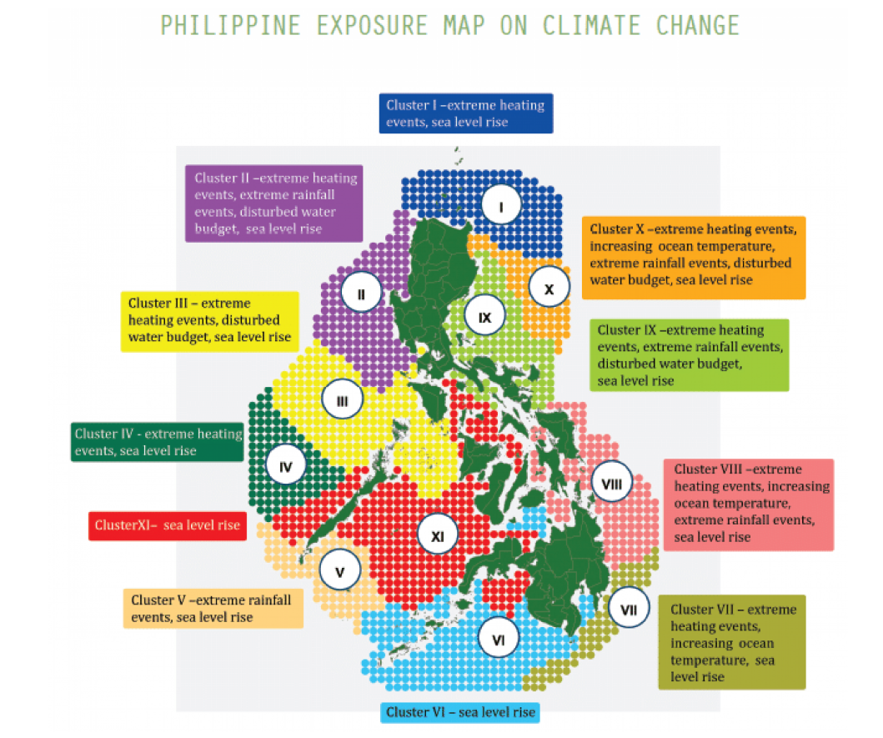
Source: DENR, Philippines, 2014

Listing the ten deadliest typhoons in the Philippines between 1947 and 2014, five out of the 10 have occurred since 2016, affecting and displacing thousands of people every time. The deadliest storm on record is Typhoon Haiyan, known locally as Typhoon Yolanda, which was responsible for more than 6000 lost lives and over four million displaced citizens, and $2 billion in damages in 2013 (Climate Reality Project, 2016)

Because of its mere geographical location, the Philippines experience an average of 20 tropical cyclones. Over the past decade, the number of tropical storms making landfall in the country is becoming more frequent and more severe and this trend is attributed to climate change effects.

It is only the country’s coral reefs and mangrove ecosystems that remains to be the best natural buffers against various forces such as typhoons. Located in the upper intertidal zones, mangroves are plant adapted to live in saline environment. Their very location also entails them to the highest amount of disturbance from various anthropogenic reasons and recently from various impacts of climate change. These facts give some indication of their ability to cope with coastal hazards, or at least recover from perturbations.

Response of mangroves to Climate change

Both the island provinces of Samar and Leyte were in the direct path of Typhoon Haiyan which led to serious damages and a large number of casualties. A small town in Eastern Samar known as General McArthur attributed the zero-casualty reported in their town due to the presence of mangrove forests that served as natural barrier between the town and the direct path of the Typhoon. This perception was widely echoed in other coastal municipalities in Eastern Visayas. Specifically, the perception that mangroves pay an important role in coastal protection was high among residence with larger, ranging from 430 to 1463 hectares and more diverse mangroves, with a biodiversity index (H’) ranging from 1.2 to 1.96 (Delfino, et al, 2015).

Damaged to existing mangrove forests in Eastern Visayas Region, directly hit by Haiyan accounts to 40 percent, majority of which are monospecific tall and rigid mangrove forests (Villamayor et al, 2016). This was further proved by Spalding, et. al in 2014 in terms of the ability of mangroves to provide coastal defense. Wider mangroves as much as hundred meters in wave can significantly reduce wave height by 13 to 66 percent per 100 meters of mangroves. While to significantly withstand against storm surges, hundred meter width of mangrove needed to significantly reduce wind and waves on top of surge. More significant cover (thousands of meters) is needed to reduce flooding impact (storm surge height is reduced 5-50 cm/km).

Structurally complex mangrove forest can reduce the height and energy of wind and swell waves passing through them. Both from the experience in Typhoon Haiyan and more controlled studies prove that complex mangrove stands with young and small mangroves can already be effective – more effective than single-aged and monospecific stands.

The Philippine EIA system

The Environmental Impact Assessment (EIA) System in the Philippines, officially referred to as the Philippine EIS System (PEISS), was established under Presidential Decree (PD) 1586 on 11 June 1978 stating that no person, partnership or corporation shall undertake or operate any such declared environmentally critical project or area without first securing an Environmental Compliance Certificate (ECC).

In 2007, a joint review of the World Bank and the Asian Development Bank revealed that the legal and institutional frameworks of the PEISS were sound and robust. While the ability of the system to be a good planning tool can be further improved, the system nonetheless is recognized as both effective and efficient. The PEISS was reviewed to have all the basic elements of a good Environmental assessment system, such as the presence of screening, scoping, independent review, public participation, disclosure, and monitoring.

The PEISS is a powerful tool that can manage ecosystem services that may be provided by mangroves which will subsequently increase the resilience of small coastal communities to climate change. This could include the following:

Strengthening baseline assessment of mangroves

Currently, information typically includes biodiversity (e.g. species richness, importance value, etc). Baseline information could also be extended to site productivity indicators such as soil properties, salinity levels, and elevation. These information will prove to be valuable in future monitoring as well as options for enrichment or rehabilitation.

The current PEISS does not include the assessment of ecosystem services in the preparation of the EIS. Ecosystem services, if discussed in the EISs, are insignificantly incorporated in the over-all discussion of baseline information. Incorporating ecosystem services, primarily of important ecosystem such as mangroves, can provide better understanding of the services including protective functions these ecosystems provide. Specifically, this can include information on previous exposure of the ecosystem to climate change related events.

Inclusion of information on local community’s perception of nearby mangrove areas is also important in establishing perception on the value of the mangroves. This should also gauge the ability of the key members of the community to be part of the impact assessment system in terms of public participation including taking part in monitoring activities post EIA.

In the Philippines, where strategic impact assessment is yet to be strengthened, there is a need for consolidated information on coastal resources including information on existing mangroves – their risk to climate change related events, with or without the proposed project. In the country, it is not unusual to find different EISs prepared by different preparers for different development projects co-located in larger ecosystem (i.e., along the same waterbody such as bays) resulting in highly fragmented information unusable for more important decision making.

Strengthening mitigation measures through the implementation of mitigation hierarchy

The protection of mangroves in the Philippines is set in the legal background of a national law that prohibits the cutting of mangroves by the virtue of Republic Act 7161 (1991). It is therefore imperative that mangrove forests be avoided by project development at all cost. However, when all options has been exhausted and portion of a mangrove forest needs to give way to national interest, options for mitigation should be fully exhausted. This includes earthballing and transfer of affected individuals. Project proponents need to show proof of closely monitoring survival of transferred individuals and implementation of uniform replacement ratio of 1:100 (1 dead trees to be replaced by 100 seedlings). This is commonly practiced in the Philippines and without proper technical guidance by restoration ecology specialists, this could also prove to be quite daunting for project proponents.

Coastal communities should also be involved in biodiversity offset efforts identified by impact assessment. Learning from the experience of these communities from Typhoon Haiyan and other similar weather perturbations, public participation should be stronger now, more than ever.

Strengthening Environmental Management Plan of mangroves rehabilitation

In the midst of climate change impacts to coastal communities, the functionality of mangrove forests was perceived to have a high in terms of providing protective and productive functions to vulnerable coastal communities. This realization initiated renewed efforts on mangrove rehabilitation in the Philippines.

Ironically, in a tremendous effort to accomplish physical target in terms of coverage, previously mangrove rehabilitation efforts have been considered to be of inferior growth and performance. This is attributed to ecological problems that arose from neglect to pay attention to each of the ecological requirements of mangrove species used (Samson and Rollon, 2008) as well as the lack of understanding of the site where mangrove rehabilitation is undertaken. Even posing a threat to the other ecosystems mangrove support and needed (i.e. mangrove plantation in seagrass meadows).

For this very reason, in an effort to curb the adverse impact of climate change, many planted without understanding, resulting in the loss of valuable resources i.e., time, money and community’s effort, therefore, robbing vulnerable coastal communities the assurance that these efforts will help in abating the adverse effect of climate change.

A sound Biodiversity Management Plan should be incorporated in the Environmental Management Plan of EIS.

Conclusion

The recent climate change events experienced in the Philippines should provide valuable lessons on how to properly manage mangrove ecosystem in the country. While the country’s environmental managers are now more focused on mangrove conservation and rehabilitation efforts, the very same lessons should provide valuable guidance to EA practitioners on how to contribute to this national and even global efforts.

References

Food and Agriculture Organization, 2007. The World’s Mangroves 1980-2005. A thematic study prepared in the Framework of the Global Forest Resources Assessment.

Kreft S, Eckstein D, Dorsch L and Fischer L. 2016. Global Risk Index 2016. Who suffers most from extreme weather events? Weather related Loss Events in 2014 and 1995 to 2014. www.germanwatch.org/en/cri Accessed 08 February 2017.

Climate Reality Project. 2016. https://www.climaterealityproject.org/blog/how-climate-change-affecting-philippines Accessed 08 February 2017.

Delfino RJ, Carlos C, David L, Lasco R, Juanico DE. 2015. Perceptions of Typhoon Haiyan-affected communities about the resilience and storm protection functions of mangrove ecosystems in Leyte and Eastern Samar, Philippines. Climate, Disaster and Development Journal. Vol 1 Issue 1.
https://www.cddjournal.org/article/view/vol01-iss01-004 Accessed 28 January 2017

Villamayor, BM, Rollon R, Samson M, Albano, GM, Primavera J. 2016. Impact of Haiyan on Philippine mangroves: Implication to the fate of the widespread monospecific Rhizophora plantations against strong typhoon. Oceana and Coastal Management. 134.1-14.

Samson M and Rollon R, 2008. Growth Performance of Planted Mangroves in the Philippines: Revisiting Forest Management Strategies”, Ambio Vol 34 No. 4.

Spalding M, Mclvor A, Tonnejick FH, Tol S and van Eijk P. 2014. Mangroves for coastal defence. Guidelines for coastal managers for policy makers. Published by Wetlands International and The Nature Conservancy. 42 p. http://www.nature.org/media/oceansandcoasts/mangroves-for-coastal-defence.pdf Accessed 28 January 2017.

World Bank Report. 2009. The Philippines: Country Environmental Analysis.

